P4 M2

**Introduction**

In this assignment, I will be recommending a laptop for Julien, who is going to start a web design and development course for four years. I will be recommending him either a laptop, computer or mac with the appropriate software. For M2, I will need to compare the recommended device with another one and justify why I chose this laptop for him.

|  |  |
| --- | --- |
| HP ENVY 17-j053ea 17” Laptop - Silver | Actual Price: £899.99 |
| Icon: Intel Laptop Processor - Third Gen Core i3<http://brain.pan.e-merchant.com/3/8/21492783/l_21492783.jpg> | | Specification |  | | | | --- | --- | --- | --- | | Processor |  | : | Intel® Core TM i7 | | RAM |  | : | 12GB | | Hard drive |  | : | 1 TB | | Screen |  | : | 17” | | Operating System |  | : | Windows 8.1 | | Platform Technology |  | : | Laptop | | CPU Speed |  | : | 2.4GHz | | Cache |  | : | 6 MB | |
|

In this table above, it demonstrates the key aspects of what the laptop includes. I recommend this laptop, as it is portable easy and key to use because it could last more than 4 years. The laptop is powered by the 2nd generation Intel Core i7 that makes light work of everyday tasks such as typing up documents. The Core i7 is Intel's current most powerful processor; most have clock speeds or GHz. The advantages using Intel Core i7 is:

* **Integrate four Cores (latest Core i7 processor incorporate 6 cores)**
* **Speed ranges from 2.66GHz to 3.33GHz**
* **Front Side Bus Speed include 2GHz, 4.8GHz or 6.4GHz**
* **Support DDR3 main memory**
* **1MB L2 and 8MB L3 cache**
* **Enhanced Intel SpeedStep Technology**
* **Virtualization Technology**
* **Streaming SIMD Instructions (MMX)**
* **Over clocking capability**

The 12GB RAM allows you to multitask on any program and save many documents, which is needed for Julien. Windows 8.1 introduces new applications; start screens, which makes this laptop more natural. In terms of cost, just the laptop, I think it is worth the money because putting all the key features of the laptop together, makes it worthwhile. The company is HP as I think it lasts long and it should be in the top 10 of the top brands. Customers think that they are, “very pleased with my laptop purchase.” The benefits of using a laptop is that it is portable for users. Julien can complete his work anywhere. Even if he is on the way to University and an assignment is due in the morning, Julien can take his laptop with him and complete it on the train/travel/use at university as well. Some of the issues of using the laptop is the internet connectivity. Because this platform is portable, you will need internet connectivity wherever you go. The internet requires Wi-Fi and that is private, which requires a password. He will need a wireless router that connects to the internet wirelessly.

Therefore, you would need internet at your house and/or University to use the internet. As this is a laptop, I think that getting insurance for this laptop is necessary. It includes a 5-year deal with a payment of £300 for the full 5 years. The insurance includes if any damages to the laptop, PC World would fix the problem. They also have a call line that Julien can call if there is a minor issue that he is worried about on the phone. I think it is valuable because Julien’s 4-year course with the insurance, the laptop would last. If any problem occurs, Julien would need to save his work on an external storage device i.e. USB. I would not like to choose any output devices for Julien because it would be an additional weight to when he is carrying his laptop. The only output device I chose is an USB.

|  |  |
| --- | --- |
| Software & Additional | |
| Cloud Service & McAfee LiveSafe | £38.99 with Laptop |
| Microsoft Office | £99.99 |
| USB | £8.00 |
| Adobe Dreamweaver | £400.00 |



I think that the recommendations that I have made is suitable for Julien because Adobe Dreamweaver is the program that is used for creating websites. McAfee needs to be renewed each year for the computer to stay protected from viruses. I have recommended Microsoft Office because Julien is doing a course, it would need written work with creating websites. Cloud Storage is a backup service. USB could be an extra safety backup service.

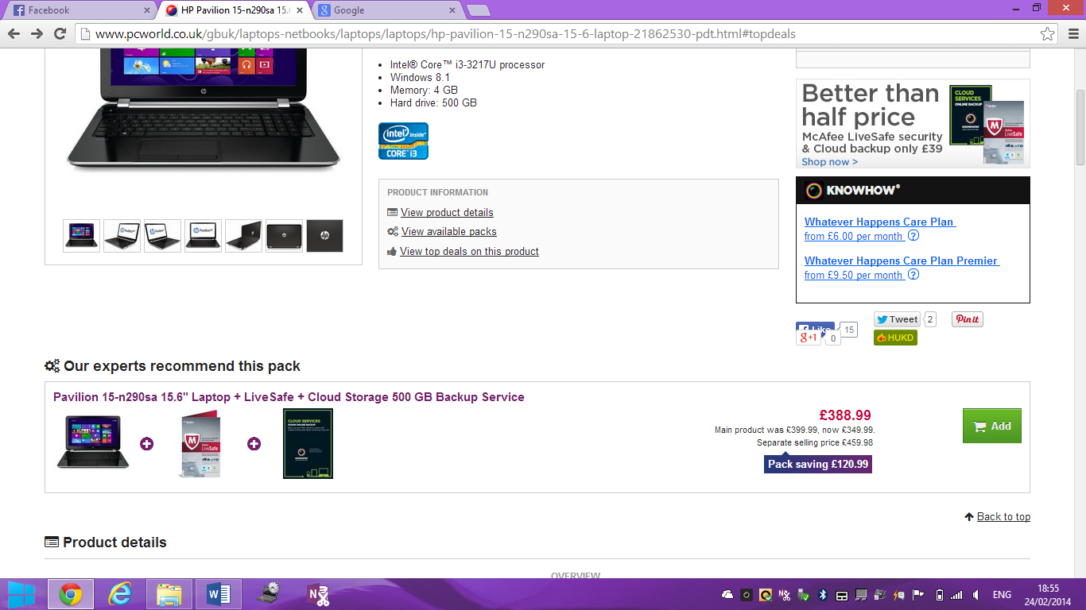

I have just about met the budget, £1750, leaving behind £4.02 left. I included the £300 insurance.

**TOTAL COST: £1746.98**

**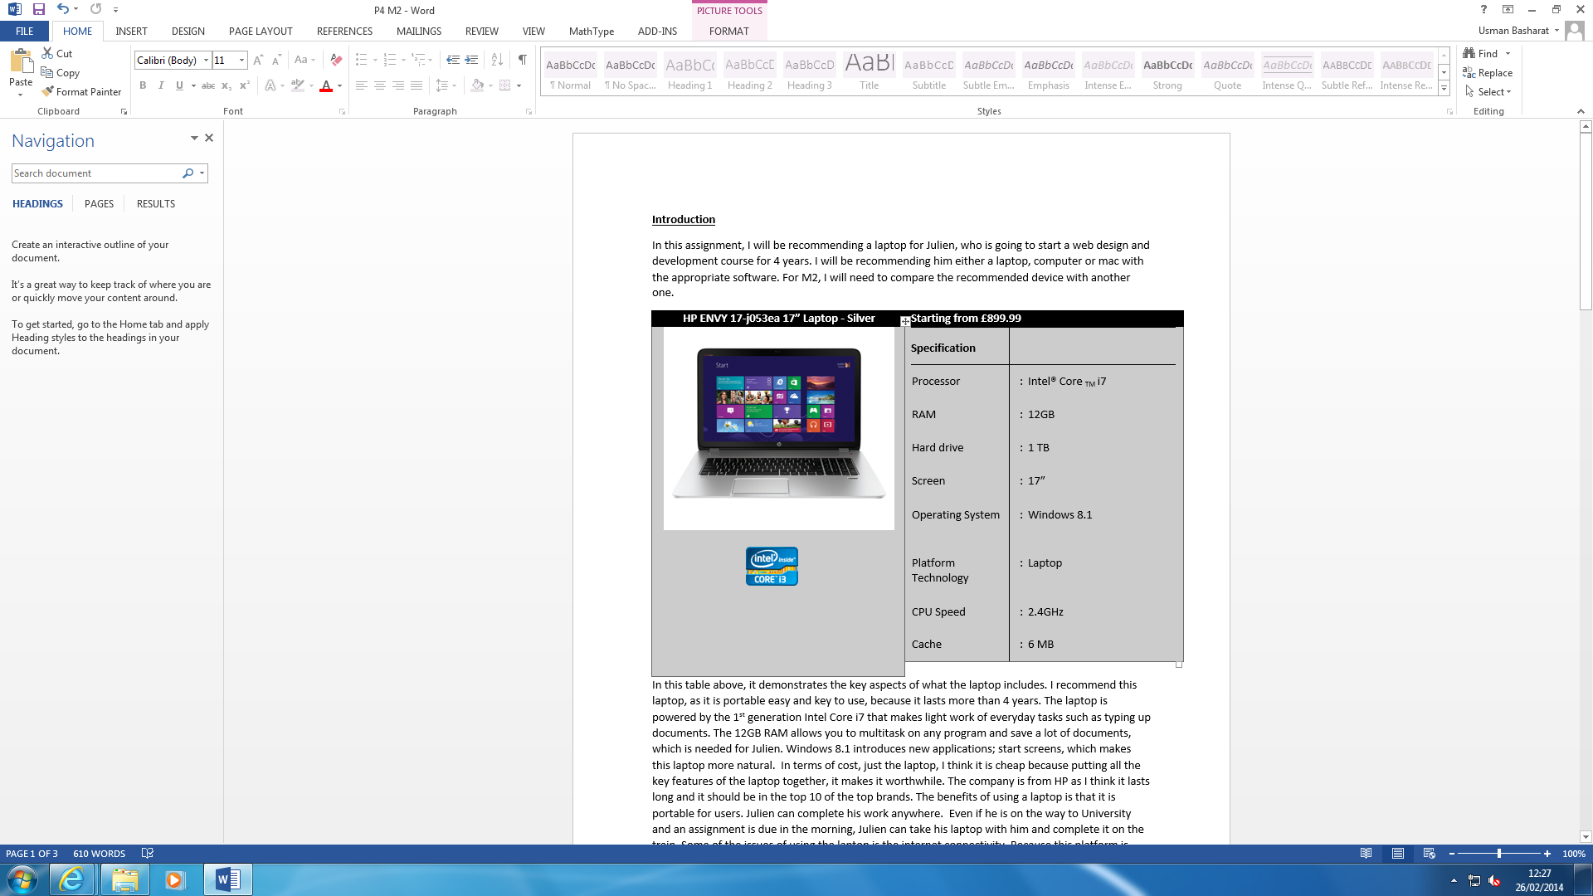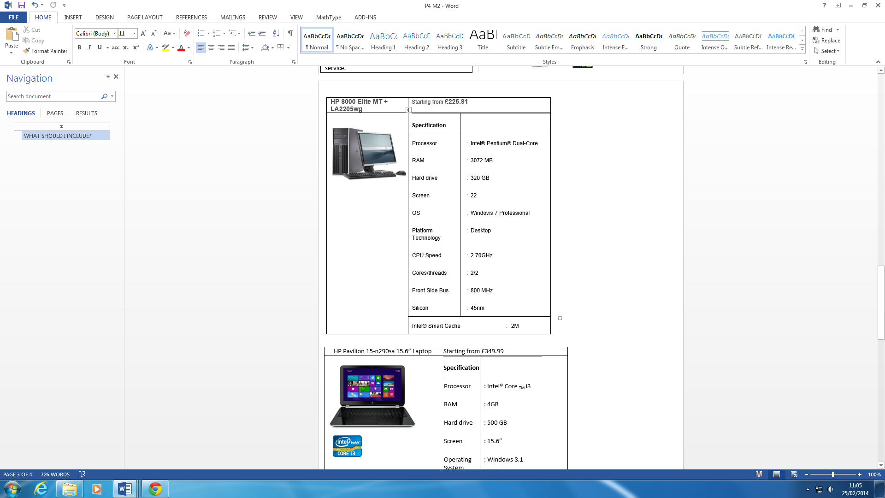*Comparison***

Figure 1.2

Figure 1.1

These two images are specifications for a desktop system (HP Envy) and laptop. As you can see, they both have completely different specs to each other e.g. the RAM for Figure 1.1 has 12GB whereby Figure 1.2 has only 3GB of RAM. In my opinion, this is important as it allows the computer to store data on the computer. The higher RAM you have, the more you can save on the computer. I think that my suggested laptop is better than the comparison because computers are updated every day. By having the latest one, you would any problem to save more on the laptop.

The operating system is the latest, Intel Core i7. This demonstrates that you can have new applications and a way faster to use the new and updated operating system. This is vital depending on which Intel you have. Intel i7 is Intel’s second smartest processor for serious multitasking. The processor makes the main decisions for basic tasks to be complete. Same with the RAM, the better the processor, the faster the performance it is. For example, Intel i3 ranges from 1.60 GHz to 3.40 GHz whereas Intel i7 is 2.40 GHz to 3.40 GHz. The price is a big difference. My recommendation is £899.99 and the other comparison laptop is £225.91.

**Conclusion**

In conclusion, I think that the specification for the laptop I have recommended is the most suitable. It will last longer than expected as you can have the insurance as a backup. Having HP, as your company, is great because it is in the top 10 of best companies. Customers think that they are, “The colours exhibited in this model are just OUTSTANDING! So bright, crisp, and clear. Absolutely fan flipping’ tastic for photos, videos, and graphics. Even Skype is more vivid with this laptop!” My final recommendation would be this laptop, HP Envy, because the RAM has enough space to store many documents; the operating system is Windows and has the latest version. The benefits of increasing RAM is that you would be able to maintain more simultaneously open applications, work with larger databases, spreadsheets, etc. Video processing would be faster with the additional memory. Audio processing could also see a benefit. The system itself could use more RAM for caching which would affect many system-level processes. There are many other potential benefits, but they all depend on how you use your system.

Reference

<http://www.pcworld.co.uk/gbuk/laptops-netbooks/laptops/laptops/hp-envy-17-j053ea-17-laptop-silver-21492783-pdt.html>

<http://www.amazon.co.uk/product-reviews/B008SPNENY>

<http://www.amazon.com/review/R37RSN1WN7IZSX/ref=cm_cr_pr_viewpnt/177-2682805-6979346#R37RSN1WN7IZSX>